**SLAM**

Simultaneous localization and mapping (SLAM) is the computational problem of constructing or updating a map of an unknown environment while simultaneously keeping track of an agent’s location within it.

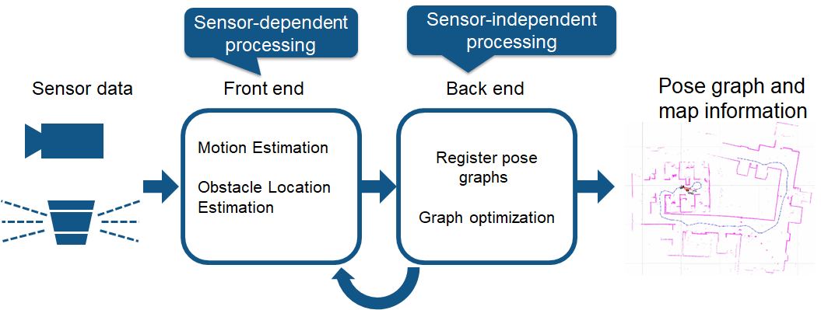

**Sensor**

Simple Camera

Cameras provide a large volume of information; they can be used to detect landmarks (previously measured positions). Landmark detection can also be combined with graph-based optimization, achieving flexibility in SLAM implementation.

**Algorithm**

ORB-SLAM:

* **Map Initialization**: ORB-SLAM starts by initializing the map of 3-D points from two video frames. The 3-D points and relative camera pose are computed using triangulation based on 2-D ORB feature correspondences.
* **Tracking**: Once a map is initialized, for each new frame, the camera pose is estimated by matching features in the current frame to features in the last key frame. The estimated camera pose is refined by tracking the local map.
* **Local Mapping**: The current frame is used to create new 3-D map points if it is identified as a key frame. At this stage, bundle adjustment is used to minimize reprojection errors by adjusting the camera pose and 3-D points.
* **Loop Closure**: Loops are detected for each key frame by comparing it against all previous key frames using the bag-of-features approach. Once a loop closure is detected, the pose graph is optimized to refine the camera poses of all the key frames.